AI-Based Smart Traffic Congestion Prediction and Signal Optimization
Dev Kumar¹, Asheesh Kumar², Shyamji Yadav³, Bibhu Krupa Pradhan⁴, Saurabh Kumar Risi⁵, Rekha Baghel⁶
School of Computer Science and Engineering, IILM University, Greater Noida, India
Project Guide and Corresponding Author: Mrs. Rekha Baghel(Rekha.baghel.iilm.edu)

Abstract
Urban traffic congestion causes delays, fuel consumption and environmental costs. This study evaluates a machine-learning workflow for estimating trip-average vehicle speed and classifying traffic density using a Delhi trip-level dataset of 4,000 records. Four regression algorithms—Linear Regression, Decision Tree, Random Forest and Gradient Boosting—were compared in the supplied notebook. The recorded preliminary Gradient Boosting result is MAE = 3.502 km/h, RMSE = 4.590 km/h and R² = 0.929; a Random Forest classifier recorded 78% accuracy across four density classes. These values are exploratory because the original feature sets contain target-related information leakage and model selection used test-set performance. The revised methodology excludes cross-target features and specifies training-only cross-validation before final testing. Since the dataset describes trips between areas rather than individual junction approaches, the study does not claim a validated signal optimiser or demonstrated real-world congestion reduction. A simulation-based signal-control evaluation is identified as future work.
Keywords—Traffic congestion; machine learning; traffic speed estimation; density classification; Gradient Boosting; Random Forest; trip-level data; model evaluation.

1. Introduction
Traffic congestion is a persistent challenge in large urban areas. Variations in road type, trip distance, time of day, weather and travel demand can be associated with substantial differences in observed travel speed. Data-driven models can help identify these patterns and provide estimates that may support later traffic-management tools.
This work examines a student-developed machine-learning workflow using a Delhi trip dataset. The implemented notebook has two tasks: (1) estimate average trip speed as a continuous value and (2) classify a trip into one of four traffic-density categories already present in the dataset. The work compares several regression algorithms and evaluates a Random Forest classifier.
The distinction between a trip-level model and a junction controller is important. Each record describes a trip from a start area to an end area; it does not provide vehicle counts for each approach at a specific signalised intersection. Therefore, the current dataset and notebook cannot directly determine phase-level green times. Signal optimisation remains a future system extension and is not presented here as an implemented or experimentally validated component.

1.1 Problem Statement and Objectives
The study investigates whether contextual trip features can estimate average speed and distinguish existing traffic-density categories. Its objectives are to: (i) inspect and summarise the dataset; (ii) preprocess numerical and categorical features through Scikit-learn pipelines; (iii) compare four regression models using MAE, RMSE and R²; (iv) evaluate a Random Forest density classifier using accuracy, precision, recall and F1-score; and (v) identify methodological and data limitations that must be addressed before the models are used in an operational traffic system.

2. Related Work
Prior research on intelligent transportation systems covers traffic-flow forecasting, adaptive signal control, machine-learning-based traffic management and reinforcement learning. Surveys of AI-based adaptive signal control discuss the potential of data-driven strategies while noting challenges in scalability, evaluation and real-world deployment [5], [10], [15]. Work on graph neural networks and spatiotemporal models studies how traffic observations across locations and time can be used for forecasting [10], [13]. Other studies explore machine learning for actuated signal forecasting and reinforcement-learning-based signal control [11], [12], [14].
The present study is narrower than those signal-control systems. It compares conventional supervised learning models on trip-level records and does not claim a contribution in live traffic sensing, future-time forecasting, or intersection-level signal control. A meaningful next step is to connect independently validated estimates to appropriate approach-level observations and evaluate a controller against a clearly specified baseline in a traffic simulator.

3. Dataset
The notebook loads delhi_traffic_features.csv from the Kaggle dataset page associated with user uday9081: https://www.kaggle.com/datasets/uday9081/delhi-traffic-dataset. The source should be checked for its data-collection procedure and whether the records are observed, generated or simulated; that provenance is not established by the notebook itself and should not be inferred.
The loaded file contains 4,000 rows and 10 columns. The fields are Trip_ID, start_area, end_area, distance_km, time_of_day, day_of_week, weather_condition, traffic_density_level, road_type and average_speed_kmph. The notebook reports zero missing values and zero duplicate rows. Average speed ranges from 4.8 to 93.3 km/h, with a mean of 28.0853 km/h. Density labels are distributed as follows: High 1,348; Medium 1,055; Very High 979; and Low 618 records.
These records describe trips between areas, for example an origin and destination area with a trip distance and average speed. They do not represent time-stamped observations from a single road arm or junction. The file has categorical time-of-day and weekday/weekend fields, but no exact timestamp suitable for chronological forecasting or a time-based train-test split.

4. Methodology
The methodology comprises dataset collection and inspection, task-specific preprocessing, supervised model development, leakage-controlled validation, and evaluation. It addresses two implemented trip-level tasks—average-speed estimation and traffic-density classification—and separately specifies the additional steps required for a future intersection-level signal-control experiment. The current trip dataset does not itself demonstrate signal optimisation.

4.1 Data Collection
The study uses the Delhi Traffic Dataset available through Kaggle (uday9081). The supplied dataset contains 4,000 records and 10 attributes: Trip_ID, start_area, end_area, distance_km, time_of_day, day_of_week, weather_condition, traffic_density_level, road_type, and average_speed_kmph. The two supervised tasks are (i) estimating average trip speed in km/h and (ii) classifying traffic density into Low, Medium, High, and Very High. The data source documentation should be checked to establish whether the records are observed, generated, or simulated; this provenance cannot be inferred from the notebook alone.

4.2 Data Preprocessing
Data quality checks cover data types, missing values, duplicate rows, and plausible value ranges. Trip_ID is excluded from predictive features because it is an identifier. Numerical features are imputed using the median, while categorical features are imputed using the most frequent category and transformed using one-hot encoding with unseen categories ignored. Preprocessing is fitted on the training data within a Scikit-learn pipeline to prevent information from the test set influencing training.
Feature selection is task-specific to reduce target leakage. For speed estimation, traffic_density_level is excluded because it is closely related to speed and may not be independently available at inference time. For density classification, average_speed_kmph is excluded because it is strongly associated with the density label. The remaining contextual variables are distance_km, start_area, end_area, time_of_day, day_of_week, weather_condition, and road_type, subject to confirmation that each is available at prediction time.
The data are split into training and held-out test subsets using an 80:20 split with a fixed random seed for reproducibility. For classification, stratification is used to preserve the approximate distribution of density classes. Because the dataset contains no exact timestamps, this random split does not support claims of chronological or future-time forecasting.

4.3 Model Development

4.3.1 Traffic-Speed Estimation
Average speed (average_speed_kmph) is the continuous target. Four regression algorithms are compared: Linear Regression as a baseline, Decision Tree Regressor for nonlinear decision rules, Random Forest Regressor as a tree ensemble, and Gradient Boosting Regressor as a sequential ensemble. All models use the same task-specific input features and training partition. Hyperparameter selection and model comparison are conducted using cross-validation on the training data only. The held-out test set is reserved for final evaluation and is not used to choose the best model.

4.3.2 Traffic-Density Classification
Traffic_density_level is the categorical target with four classes: Low, Medium, High, and Very High. A Random Forest Classifier is used as the initial classifier. Trip_ID and average_speed_kmph are excluded from its inputs. The classifier is trained on the training partition, with stratified splitting and training-only validation used to support reproducible model selection. A confusion matrix and class-wise metrics are reported so that differences between classes are not hidden by overall accuracy.

4.4 Evaluation Metrics
Regression is evaluated using Mean Absolute Error (MAE), Root Mean Squared Error (RMSE), and the coefficient of determination (R²). Classification is evaluated using accuracy, precision, recall, and F1-score. Let n be the number of evaluated records, yᵢ the actual speed, ŷᵢ the predicted speed, and ȳ the mean actual speed.
MAE = (1/n) Σᵢ₌₁ⁿ |yᵢ − ŷᵢ|
RMSE = √[(1/n) Σᵢ₌₁ⁿ (yᵢ − ŷᵢ)²]
R² = 1 − [Σᵢ₌₁ⁿ (yᵢ − ŷᵢ)² / Σᵢ₌₁ⁿ (yᵢ − ȳ)²]
Accuracy = (TP + TN) / (TP + TN + FP + FN)
Precision = TP / (TP + FP)
Recall = TP / (TP + FN)
F1-score = 2 × (Precision × Recall) / (Precision + Recall)
For classification, TP, TN, FP, and FN denote true positives, true negatives, false positives, and false negatives under a one-versus-rest interpretation for each class. Macro averages give equal weight to each class; weighted averages account for class support. Lower MAE and RMSE indicate smaller regression errors, while an R² closer to 1 indicates stronger fit relative to the mean baseline.

4.5 Proposed Extension to Traffic Signal Optimization
The current dataset contains trip-level records between areas rather than time-stamped vehicle counts or queue measurements for individual approaches to a signalised junction. Therefore, the present models cannot directly calculate phase-level green durations or establish reduced intersection delay. Signal optimisation is treated as a proposed extension, not a completed or validated component of the current experiments.
To evaluate this extension, future work will require location-specific and preferably time-stamped intersection observations, such as approach-level vehicle counts, queue lengths, speeds, or trajectories. A controlled traffic network can then be built in Simulation of Urban Mobility (SUMO) and controlled through TraCI. A transparent decision layer may use current and predicted traffic demand to allocate green time while enforcing minimum and maximum green durations, safe phase transitions, and maximum-waiting constraints. The dynamic strategy must be compared with a defined fixed-time baseline under identical traffic demand and random seeds. Operational measures should include average waiting time, average delay, queue length, throughput, and number of stops.

4.6 Methodology Workflow
Figure 1 summarises the implemented trip-level modelling workflow and distinguishes it from the future simulation-based signal-control extension.
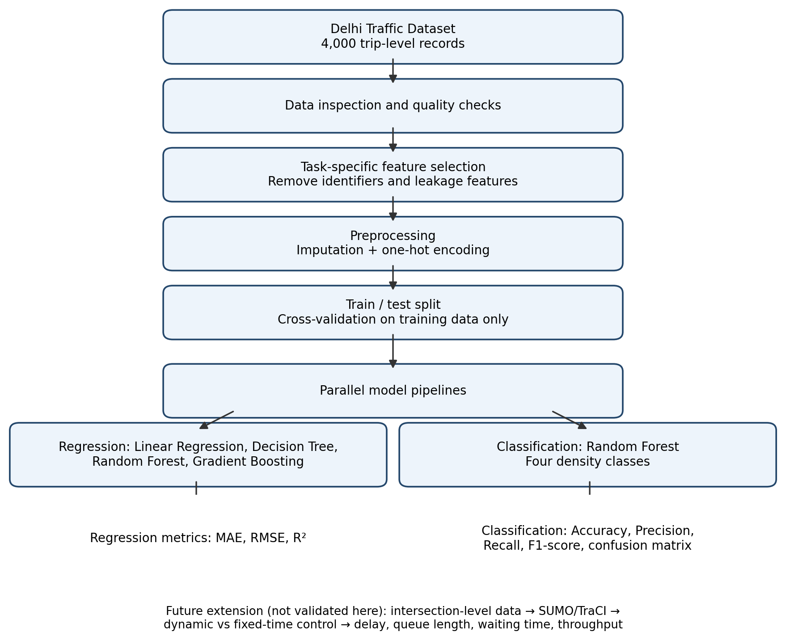
Fig. 1. Methodology workflow for trip-level speed estimation and density classification, with signal optimisation shown as future work.

5. Results and Discussion
The following values are the outputs recorded in the supplied notebook using the current feature sets and a single random split. They are included for traceability, not as final validated performance estimates. Because of cross-target feature leakage and test-set-based model selection, the results should be rerun before submission to a journal or conference.

5.1 Speed Estimation
Gradient Boosting has the lowest test RMSE among the four models in the current notebook. Its MAE is 3.502 km/h, RMSE is 4.590 km/h and R² is 0.929. Random Forest follows with MAE 3.577 km/h, RMSE 4.906 km/h and R² 0.919. Decision Tree and Linear Regression have higher errors in this split. Since the current speed model uses traffic_density_level as an input, these metrics may overstate performance for a use case where density is not known at inference time. The model comparison should be repeated after removing traffic_density_level from the speed features and selecting models using cross-validation on training data only.
Table 1. Regression results reported by the supplied notebook
Model | MAE (km/h) | RMSE (km/h) | R²
Gradient Boosting | 3.502 | 4.590 | 0.929
Random Forest | 3.577 | 4.906 | 0.919
Decision Tree | 4.596 | 6.480 | 0.859
Linear Regression | 5.133 | 6.671 | 0.851

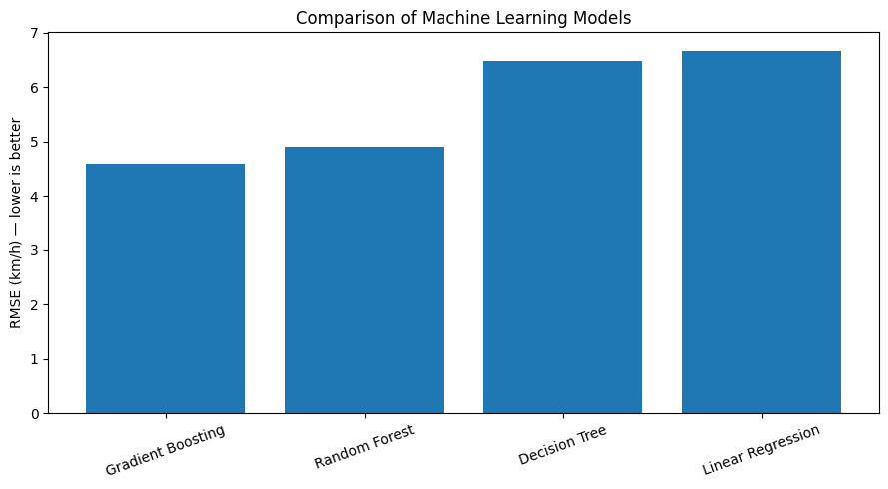
Fig. 1. Comparison of regression models using test-set RMSE (lower is better).
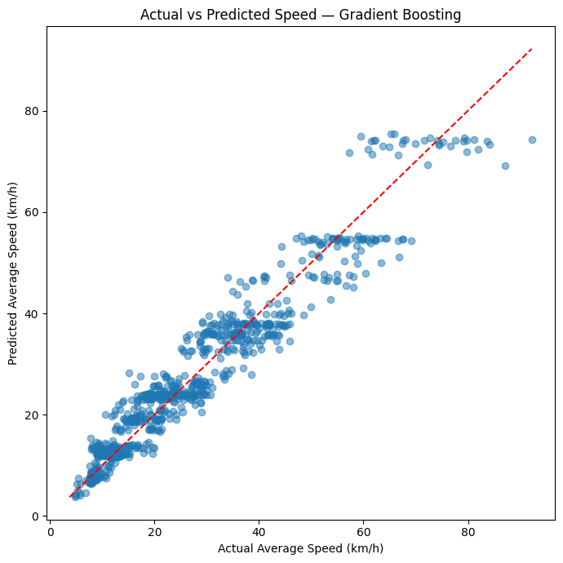
Fig. 2. Actual versus predicted average speed for the selected Gradient Boosting model. The dashed diagonal indicates perfect agreement.

5.2 Traffic-Density Classification
The Random Forest classifier reports 78% accuracy over 800 test records. The Very High class is identified most reliably (F1-score 0.96), while Low and Medium are more difficult (F1-scores 0.60 and 0.65). High has an F1-score of 0.82. This variation matters: overall accuracy alone would hide weaker performance for Low and Medium traffic. However, average_speed_kmph is included among the classifier inputs, despite its strong relationship with the density labels. These metrics therefore also require a leakage-controlled rerun before drawing conclusions about classification from contextual features alone.
Table 2. Classification report reported by the supplied notebook
Class | Precision | Recall | F1-score | Support
High | 0.81 | 0.84 | 0.82 | 269
Low | 0.68 | 0.54 | 0.60 | 124
Medium | 0.65 | 0.66 | 0.65 | 211
Very High | 0.94 | 0.98 | 0.96 | 196
Macro average | 0.77 | 0.75 | 0.76 | 800
Weighted average | 0.78 | 0.78 | 0.78 | 800

5.3 Interpretation
The notebook demonstrates that conventional models can fit patterns in the supplied trip-level dataset, and that density-class performance differs by class. However, the results do not establish future traffic forecasting, real-time monitoring, or reduced intersection delay. The dataset's provenance needs confirmation, the current models have cross-target leakage, and model selection uses test-set RMSE rather than cross-validation. These limitations restrict the strength of any conclusion. A fair follow-up experiment should remove leakage features, use a training-only cross-validation procedure, report repeated-fold mean and standard deviation, and preserve an untouched test set for final evaluation.

6. Limitations and Future Work
First, the dataset's collection process and real-world representativeness must be verified from its source documentation. Second, the notebook's current feature sets leak information between the speed and density tasks; the results must be recomputed after excluding traffic_density_level from speed inputs and average_speed_kmph from density inputs. Third, the regression model is selected using the test set, so the test set is not an independent final evaluation. Model selection should instead use cross-validation on the training set, with the test set used once at the end. Fourth, the notebook uses a random split. Since there are no exact timestamps, a time-based split and genuine future forecasting cannot be supported by this dataset. Fifth, the data contains trip-level records rather than approach-level traffic counts, so it cannot directly supply demand for signal-phase optimisation.
Future work should: (i) correct the feature leakage and rerun all experiments; (ii) use stratified splitting for classification and report repeated cross-validation mean ± standard deviation; (iii) document data provenance and any synthetic generation; (iv) collect or identify timestamped, location-specific traffic counts or trajectories; and (v) implement the signal optimiser and simulation in shared, reproducible code before reporting any control results. A signal-control evaluation should compare a defined adaptive policy against a well-specified baseline under identical traffic demand and report delay, queue length and throughput. Until that work is completed, signal optimisation is a proposed extension, not a validated result of the supplied notebook.

7. Conclusion
This paper documents an exploratory machine-learning workflow for trip-level speed estimation and traffic-density classification using a 4,000-record Delhi traffic dataset. The supplied notebook reported a Gradient Boosting RMSE of 4.590 km/h and Random Forest density-classification accuracy of 78%; these results are preliminary and require rerunning with leakage-controlled features and training-only model selection. The revised methodology defines reproducible preprocessing, validation, and evaluation procedures. Because the available records are trip-level and lack time-stamped junction observations, the study does not establish future-time forecasting or traffic signal optimisation. Future work should validate the models and evaluate a separately implemented dynamic controller against fixed-time control in a controlled traffic simulation.

References
[1] I. Dabi and N. Abuhamoud, “AI-Powered Traffic Signal Control Systems for Enhanced Traffic Flow and Reduced Waiting Time,” Wadi Alshatti University Journal of Pure and Applied Sciences, The First Conference on Roads and Traffic Accidents, pp. 36–39, 2025.
[2] R. C. R. Nampalli, “Leveraging AI in Urban Traffic Management: Addressing Congestion and Traffic Flow with Intelligent Systems,” Journal of Artificial Intelligence and Big Data, vol. 1, no. 1, pp. 86–99, 2021, doi: 10.31586/jaibd.2021.1151.
[3] K. M. Almatar, “Implementing AI-Driven Traffic Signal Systems for Enhanced Traffic Management in Dammam,” International Journal of Sustainable Development and Planning, vol. 19, no. 2, pp. 781–790, 2024, doi: 10.18280/ijsdp.190236.
[4] Y. El-Hansali, S. Farrag, A. Yasar, and D. Zavantis, “Artificial Intelligence based Smart Traffic Enforcement and Management System in urban areas,” Transportation Research Institute, Hasselt University, SSRN 4227717, 2022.
[5] A. Agrahari, M. M. Dhabu, P. S. Deshpande, A. Tiwari, M. A. Baig, and A. D. Sawarkar, “Artificial Intelligence-Based Adaptive Traffic Signal Control System: A Comprehensive Review,” Electronics, vol. 13, p. 3875, 2024, doi: 10.3390/electronics13193875.
[6] D. Sai Pooja, K. Vaishnavi, and S. Mani Sharath Chandra, “Artificial Intelligence Based Automated Traffic Management System,” Anubose Institute of Technology, affiliated to JNTU-Hyderabad, 2021.
[7] A. S. Pillai, “Traffic Management: Implementing AI to Optimize Traffic Flow and Reduce Congestion,” Journal of Emerging Technologies and Innovative Research, vol. 11, no. 7, 2024.
[8] K. V. D. Francisco, E. C. L. Robles, and H. P. B. Samson, “Artificial Intelligence for Traffic Management: A Comprehensive Review of Advances and Challenges,” 2024.
[9] A. Hussain, “AI-Driven Traffic Prediction and Congestion Control in Smart Communication Systems,” International Journal of Artificial Intelligence and Communication Networks, vol. 2, no. 1, pp. 45–62, 2026.
[10] W. Jiang and J. Luo, “Graph neural network for traffic forecasting: A survey,” Expert Systems with Applications, vol. 207, p. 117921, 2022, doi: 10.1016/j.eswa.2022.117921.
[11] F. Xie, S. Naumann, O. Czogalla, and H. Zadek, “Machine Learning Model Application and Comparison in Actuated Traffic Signal Forecasting,” Sensors, vol. 23, no. 15, p. 6912, 2023, doi: 10.3390/s23156912.
[12] C. Cai and M. Wei, “Adaptive urban traffic signal control based on enhanced deep reinforcement learning,” Scientific Reports, vol. 14, p. 14116, 2024, doi: 10.1038/s41598-024-64885-w.
[13] Q. Luo, S. He, X. Han, Y. Wang, and H. Li, “LSTTN: A Long-Short Term Transformer-based spatiotemporal neural network for traffic flow forecasting,” Knowledge-Based Systems, vol. 293, p. 111637, 2024, doi: 10.1016/j.knosys.2024.111637.
[14] S. Cai, J. Fang, and M. Xu, “XLight: An interpretable multi-agent reinforcement learning approach for traffic signal control,” Expert Systems with Applications, vol. 273, p. 126938, 2025, doi: 10.1016/j.eswa.2025.126938.
[15] X. Zhang, Z. Xiao, T. Liu, M. Liang, R. Gao, H. Li, and J. Zhang, “Reinforcement learning for traffic signal control in large-scale transportation networks: a systematic literature review,” Artificial Intelligence Review, 2026, doi: 10.1007/s10462-026-11676-6.
[16] uday9081, “Delhi Traffic Dataset,” Kaggle. Available: https://www.kaggle.com/datasets/uday9081/delhi-traffic-dataset (accessed 16 October 2026).

